

**cDOT 9.1Px Adding a Cluster to OCUM/OPM 7.1P1**

**Authors:** Ian Daniel

**Contributors: Craig Goettig**, Joel Edstrom

**Document Version:** V0.1

**Date:** June 2017

Status: Draft

**CONFIDENTIAL INFORMATION**

This document contains information proprietary to Thomson Reuters and may not be reproduced, disclosed or used in whole or part without express permission of Thomson Reuters.

© Thomson Reuters 2017

Contents

1 Introduction 3

1.1 Management Summary 3

1.2 Change History 3

1.3 Distribution List 4

1.4 Glossary 4

2 Adding The Cluster 5

2.1 Description 5

2.2 Tasks 5

2.2.1 Login to OCUM 7.1P1 5

2.2.2 Select Add Cluster From The Dashboard 5

2.2.3 Add The Cluster Details 6

2.2.4 Check The Status 7

# Introduction

## Management Summary

This document details the process used to add a cluster to OCUM/OPM 7.1P1

## Change History

|  |  |  |  |
| --- | --- | --- | --- |
| **Ver** | **Date** | **Author** | **Key Changes** |
| 0.1 | June 2017 | Ian Daniel | Initial Version |
|  |  |  |  |
|  |  |  |  |
|  |  |  |  |
|  |  |  |  |
|  |  |  |  |
|  |  |  |  |
|  |  |  |  |
|  |  |  |  |
|  |  |  |  |
|  |  |  |  |
|  |  |  |  |
|  |  |  |  |
|  |  |  |  |

## Distribution List

|  |  |
| --- | --- |
| **Name** | **Role** |
| Storage Engineering | Reviewer |
| Storage Delivery | Reviewer |
| Storage Architecture | Reviewer |

## Glossary

|  |  |
| --- | --- |
| **Term** | **Definition** |
| cDOT | clustered Data ONTAP |
| OCUM | OnCommand Unified Manager – Management application |
| OPM | OnCommand Performance Manager – Performance monitoring application |
|  |  |
|  |  |

# Adding The Cluster

## Description

In order to add a cluster to a OCUM/OPM 7.1P1 pair please follow this process.

## Tasks

The following tasks are carried out.

### ****Login to OCUM 7.1P1****

**Note:** Use your M account to login to OCUM.

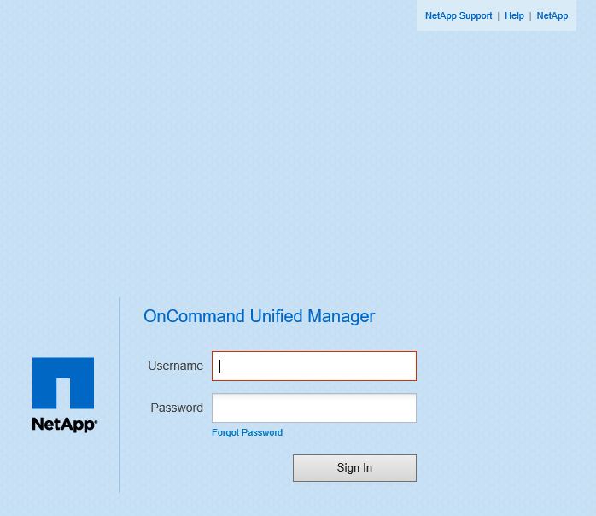

### ****Select Add Cluster From The Dashboard****

This will open a form to the right of the window in your browser. This is where you add the cDOT cluster.

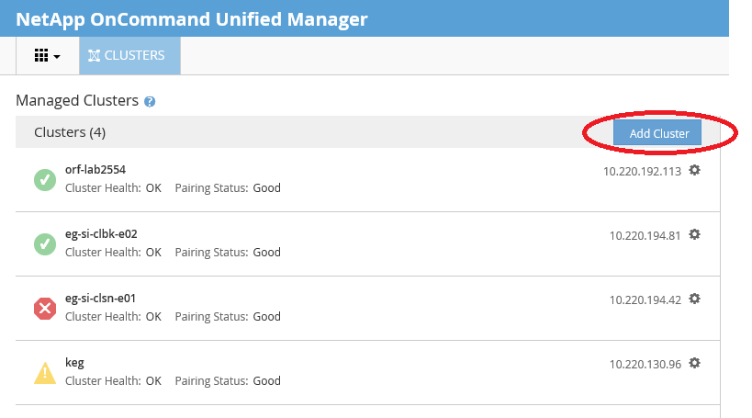

### ****Add The Cluster Details****

**Note:** You also specify the OPM server to use here as well. Each OCUM server is paired with a OPM server as highlighted below. If you fail to select this the cluster will not be added to OPM and you will have to go back in and edit it.

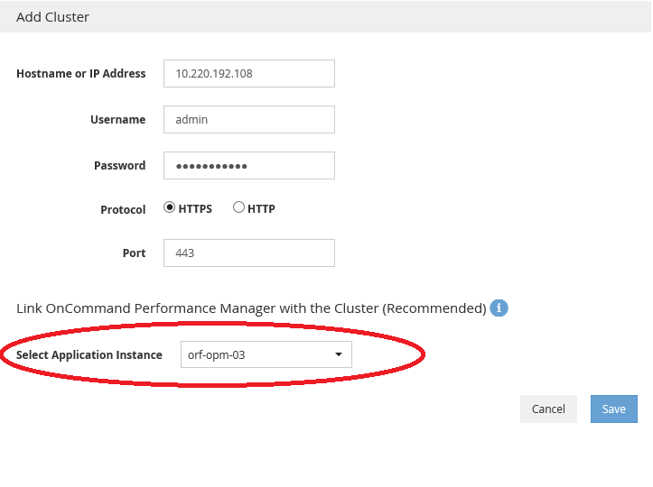

Press Save and the following messages should appear for the servers you are adding to.

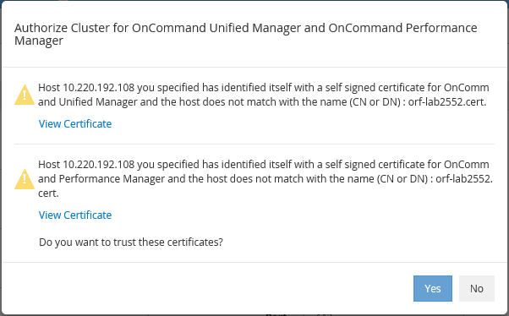

Press Yes

If the addition is successful you will see the following message.

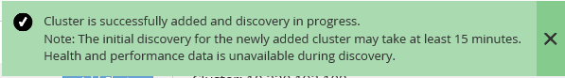

**Note:** It can take some time for OCUM and OPM to discover the cluster and nodes so don’t panic if they are not there right away.

### Check The Status

Once the cluster is added and discovered the status should look similar to the below example.

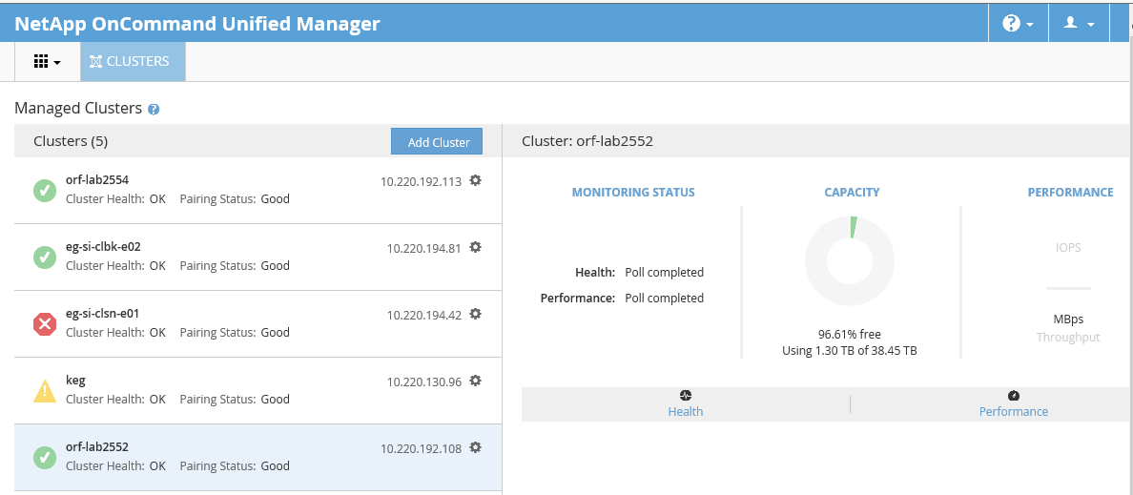

Note the pairing status, this is the status of the cluster with regard to OPM.